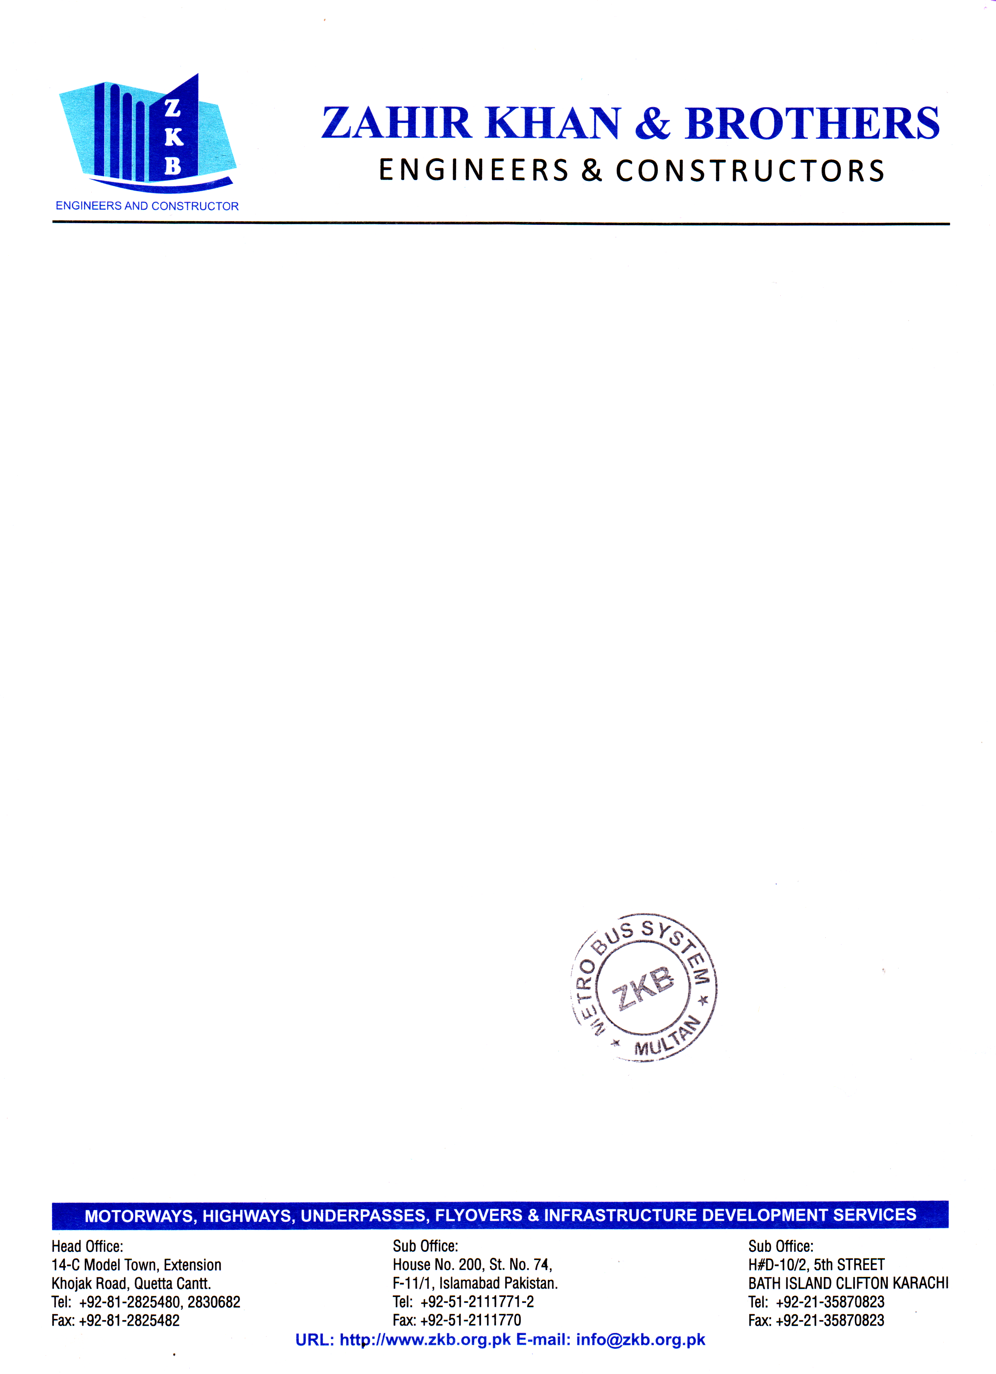

Date: <To2>

TO WHOM IT MAY CONCERN

This is to certify that Mr. <Name>, S/O <fname>, bearing CNIC No. <CNIC>, has worked as <Designation> with Zahir Khan and Brothers (From <From2> to <To2>) at Metro Bus Project . During this period his role was vital and always excellent in the assigned task, punctual and hardworking.

We wish him success in future endeavor.

Muhammad Rajab

Project Manager

Zahir Khan & brother

Multan Metro Bus Project